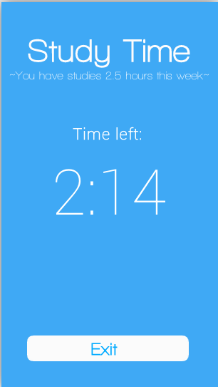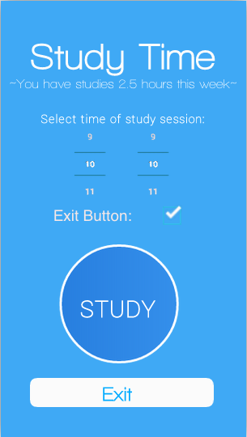

Colors:

BG: #3fa9f5

Text & Exit button: #FFFFFF

Font: Walkway ( walkway semibold.ttf)

([goo.gl/yAE8Mr](http://goo.gl/yAE8Mr))